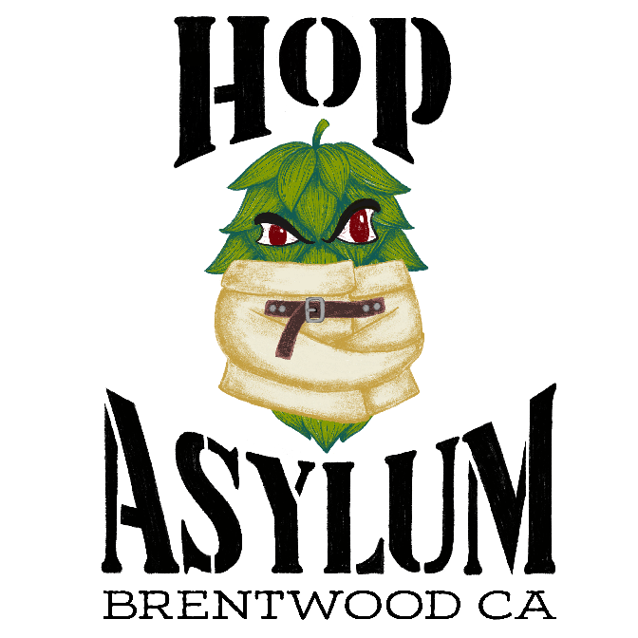

Guest Wi-Fi
Network: Hop Asylum
Password: beermenow
Small Bites
Charcuterie Board $24
3 cheeses, 3 meats, pickled stuff, crackers, and bread.
Individual Charcuterie (1 meat/cheese) $9
Pretzel & Cheese $9
Large soft baked pretzel with two sides of cheddar beer cheese sauce or Dijon mustard.
Chili Cheese Dog $6
Hot dog topped w/beer cheese sauce, chili & onion.
Hot Dog & Chips $4
Regular, polish or spicy. Served with a side of kettle chips and choice of ketchup or mustard.
Pickle Plate $5
Dill spears, spicy green beans, olives, and one rotating pickled veggie.
***Please inform us of any food allergies. Gluten free and vegan items are prepared on the same surface as wheat, meat and dairy items.
Panini Sandwiches
The Cuban $12
Pastrami, salami, swiss cheese, kraut & Dijon mustard
Chicken Pesto $11
Mozzarella, sundried tomatoes, creamy ranch, pesto, and grilled chicken breast.
Southwestern Chipotle Chicken $11
Grilled chicken breast, southwest style chipotle pesto, ranch, sundried tomatoes, and choice of cheese. (cheddar, mozzarella or swiss) (vegan sub avail)
Bacon Grilled Cheese $11
Mozzarella, cheddar, bacon, tomatoes, and ranch.
Grilled Cheese (vegan sub avail) $9
Mozzarella, cheddar & ranch
*Add kettle chips $1
Flatbreads
Margherita $11
Creamy ranch sauce topped with mozzarella, fresh basil, tomatoes, and pesto sauce.
Chorizo & Peppers $12
Creamy ranch sauce topped with mozzarella, chorizo, pepperoncini, red pepper flakes and a ranch drizzle.
Pepperoni Pizza $12
Classic pepperoni pizza flatbread style.
*Sub gluten free crust $3
*Add chicken or bacon $2
All food is made to order in our small kitchen and may take additional time during busy periods. Thank you!
***Kitchen closes at 8:45 daily.
Hard Seltzers
Ficks Craft Hard Seltzer 12oz $3
Blackberry, Cranberry, Mango, Grapefruit, Lime
Untitled Art Florida Seltzer 12oz $5
Prickly Pear Guava|Raspberry Lime|Blackberry Agave|Blueberry|Black Cherry|Blood Orange Pomegranate |Pineapple Mango.
Hard Kombucha
Local Roots Organic Raw Hard Kombucha 12oz
Island Vibes – pineapple & coconut 6% $4
Purple Haze – blueberry & ginger 6% $4

Sour Ale Spritzer
Stillwater Dry White 16oz $5.50
Sauvignon blanc grapes, lime & sea salt 4.5%
Stillwater Hot Pink 16oz $5.50
Grenache grapes, raspberry & lemon 4.5%

Wine
Campos Red Blend $6
Campos White Blend $6
Frederiksdal cherry wine 5oz $11
Bold Leaf Wine 12oz can $7
Pinot Noir, Sparkling Rosê, Pinot Gris
Untitled Art Chardonnay spritzer $6
Mead
Superstition Meadery
Marion 2oz $6
Blackberry, blueberry, raspberry mead 12.5%
Schramm’s Meadery
The Statement 2oz $8
Balaton cherry mead 14%
Red Agnes 2oz $10
Red currant mead 12%

Specialty Wine
Cold Hand Malus X Masculine 2oz $12
Decadent apple ice wine liquor 40% ABV

Not Beer
Liquid Death sparkling water $2
Red Bull $3
Ginger Ale $2
Coke, Diet Coke, Sprite $1

